R PROGRAMMING

EXPERIMENT-1
ADDITION:
AIM:
To prove the program for addition using R-tool.
PROGRAM:
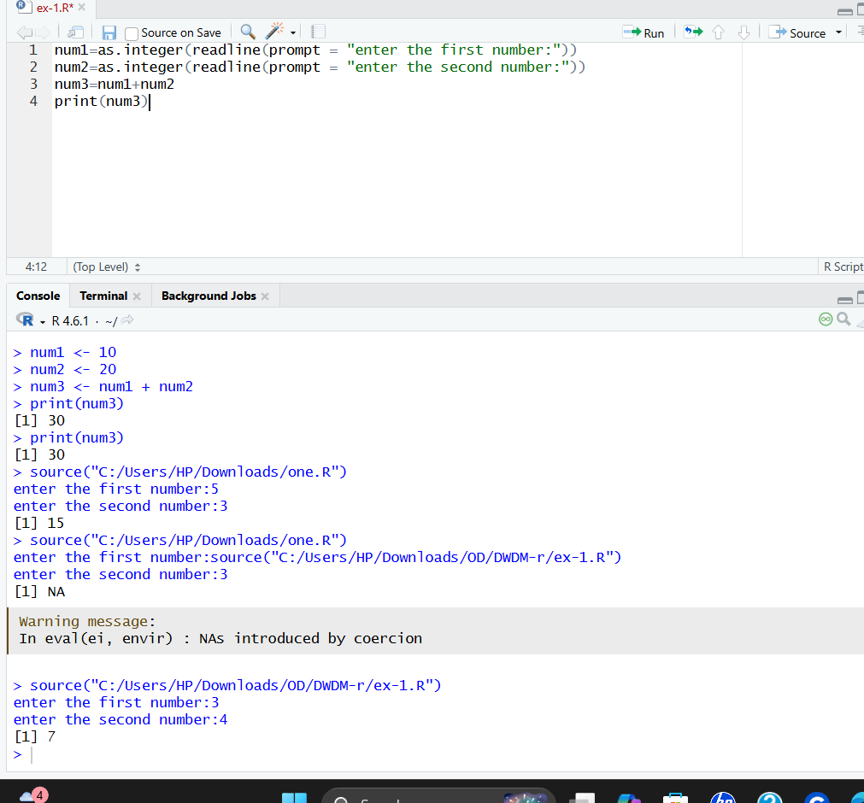
RESULT:
Thus the basic program addition is executed successfully.

EXPERIMENT-2
SUBTRACTION:
AIM:
To prove the program for subtraction using R-tool.

PROGRAM:
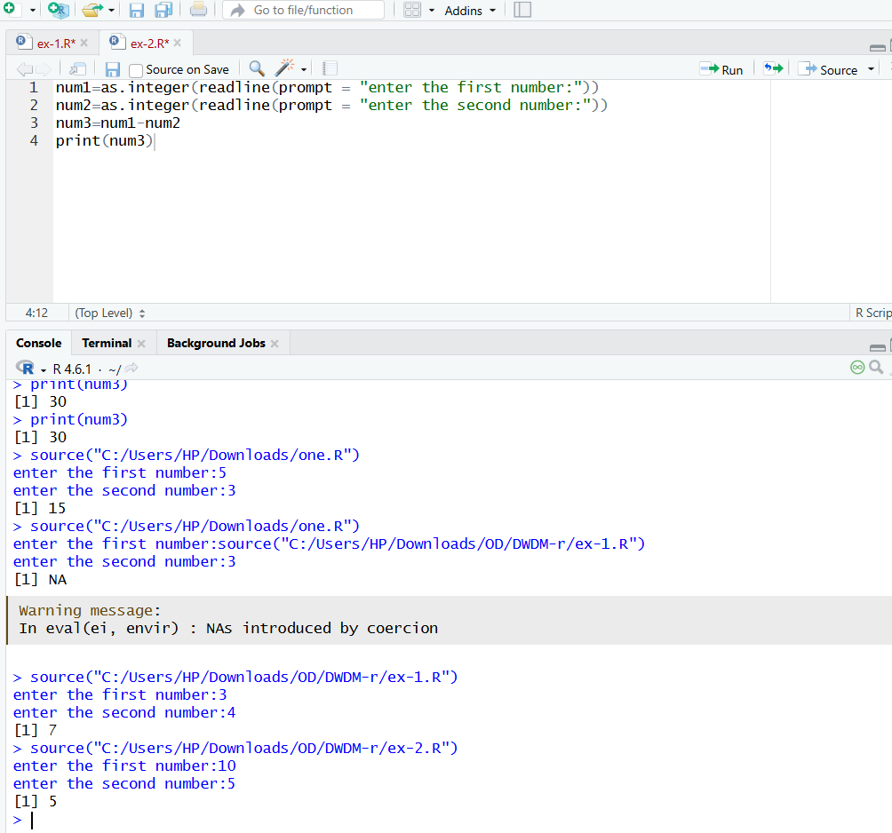RESULT:
Thus, the basic program subtraction is executed successfully.

EXPERIMENT-3
MULTIPLICATION:
AIM:
To prove the program for multiplication using R-tool.
PROGRAM:
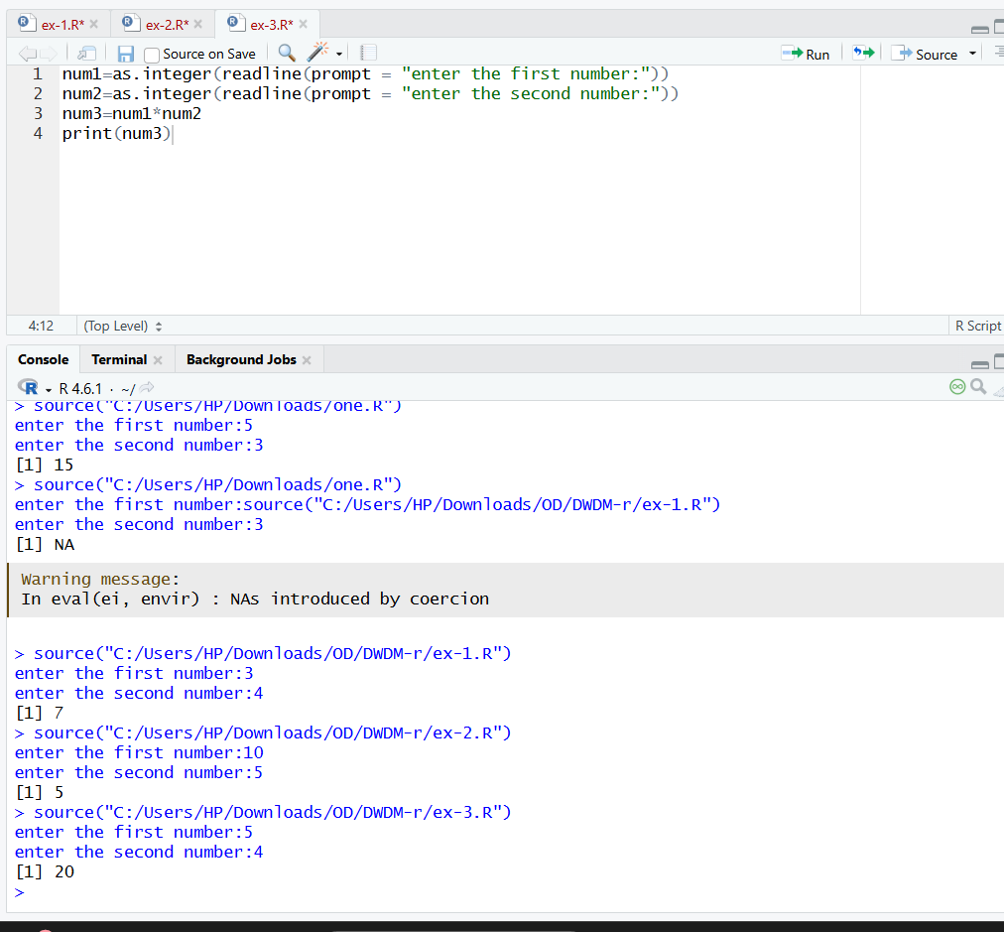
RESULT:
Thus, the basic program multiplication is executed successfully.

EXPERIMENT-4
DIVISION:
AIM:
To prove the program for division using R-tool.
PROGRAM:
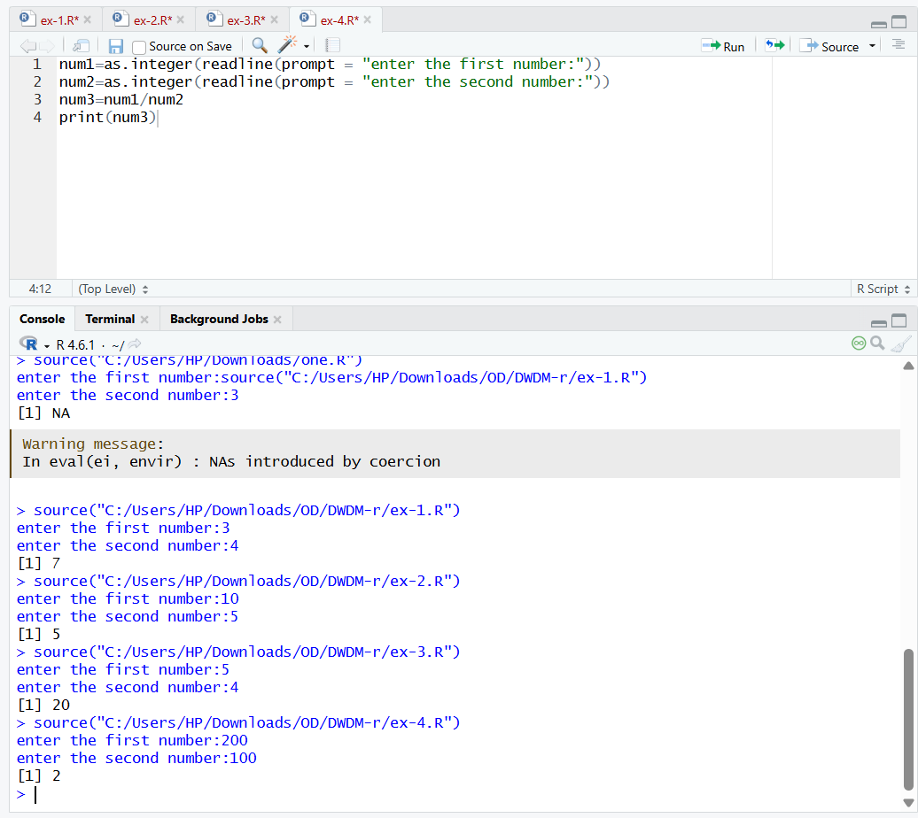
RESULT:
Thus, the basic program division was executed successfully.

EXPERIMENT-5
ODD OR EVEN:
AIM:
To write the program for odd or even using R-tool.
PROGRAM:
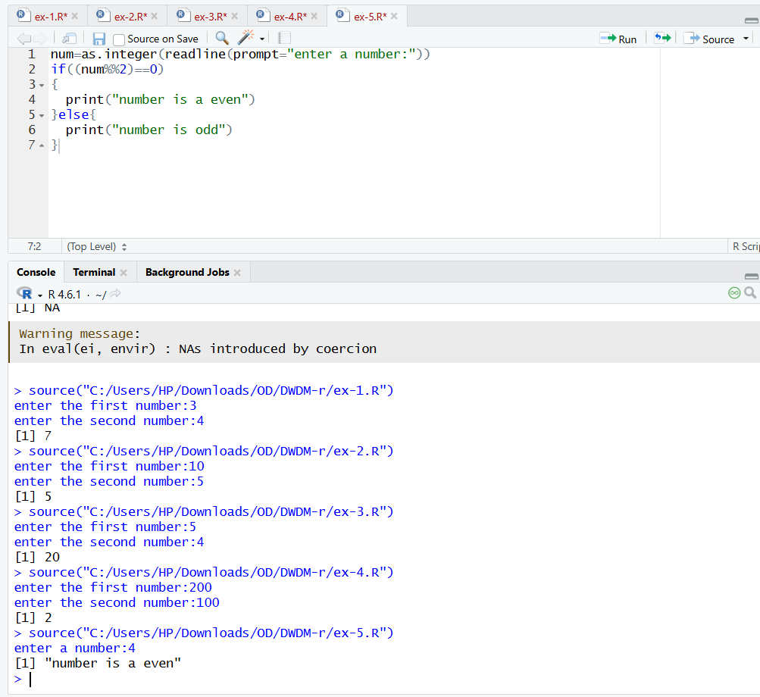
RESULT:

Thus, the basic program odd or even was executed successfully.

